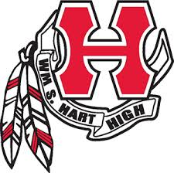 Dugout Club
Dear Hart Baseball Supporter,
Each year the Hart Baseball Dugout Club holds a Bowl-A-Thon and sells raffle tickets to help raise funds to support the Hart High School Baseball Program. This event is one of our most important fundraisers and will take place on Saturday, February 25, 2017.
Raffle tickets are sold by each player to help generate funds that go directly to the Hart High School Baseball Program. Raffle ticket prizes include donations from local businesses. This is where our request for your support becomes so important. Your donation of a gift certificate, merchandise, or some item that would make a great door prize helps to generate ticket sales. It is through the ticket sales that we are able to make improvements to our facility as well as purchase uniforms and equipment. Your contribution is vital to the overall success of our program and to our annual Bowl-A-Thon.
The support of local businesses patronized by the entire Hart High School community plays a key role in helping our athletes have a positive experience during their high school years. Without your donation, and others like it, our Bowl-A-Thon raffle would not be possible.
Thank you in advance for your thoughtful donation and support of the Hart High School Baseball Program!
Sincerely,

Jen Ventress Rick Turner
818-642-7140 President, Dugout Club
jventress@yahoo.com
Bowl-A-Thon Coordinator

P.O. Box 220364 Newhall, CA 91322 661-259-7575
The Baseball Boosters for Hart High School
Tax ID Number 95-4762826

